Web-application Trip Constructor is created to help user to choose countries where he can go, according to his nationality and visa requirements. Visa requirements are retrieved from the web and saved in the local database. User can choose his and his trip partner's nationality and get a table which contains the list of the possible destinations with the short description of the visa requirements for him and his partner. If necessary, counries can be selected and saved in the user profile.

Description of user functions:

- After opening in browser ip address: 127.0.0.1:8000 user will be redirected to the login page.
- In the login dialog there are 2 options – login or reister.
- After choosing option "Register", user will be redirected to the Register page.
- The registration form contains username, password and the confirmation of the password.
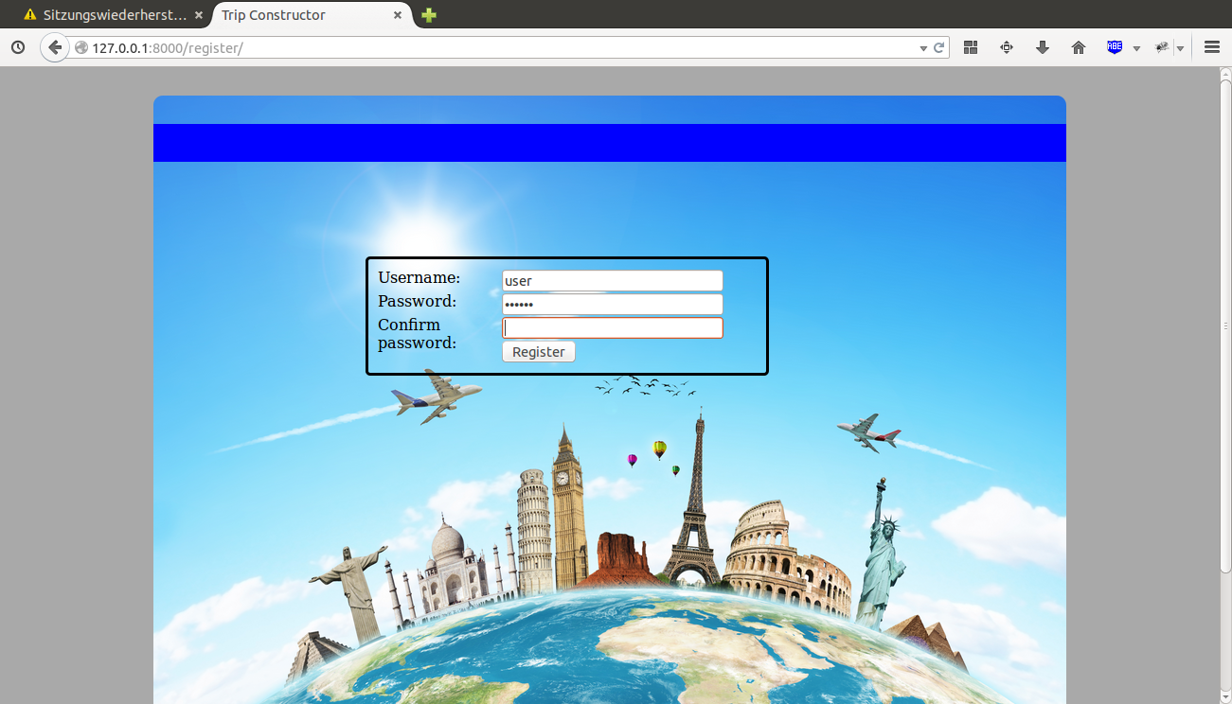
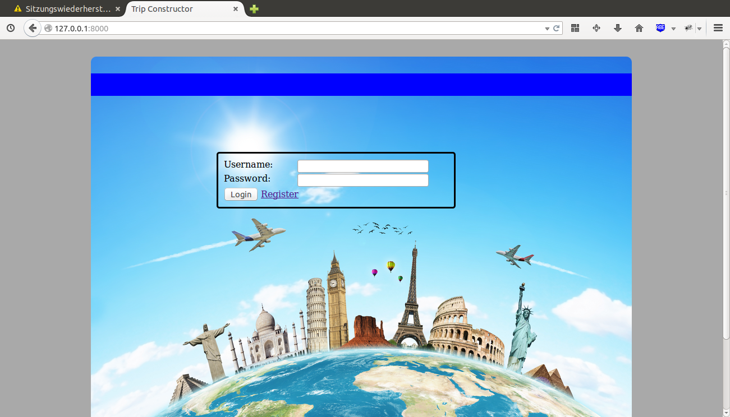
- After submitting register form user data will be saved in the database and user will be redirected back to the login page
- Login form contains 2 fields – username and password
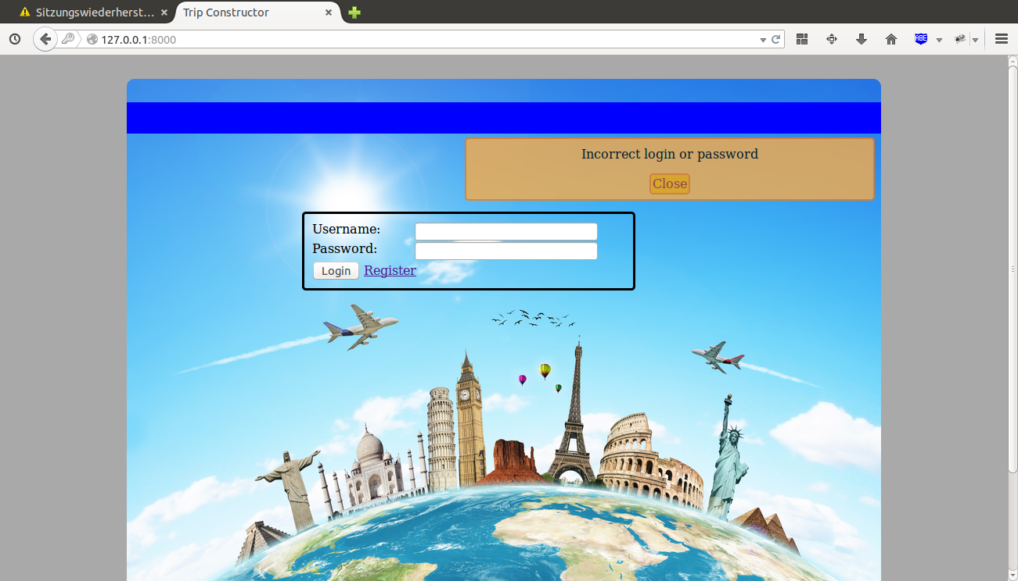
- If login data is correct, user will be redirected to Trip Constructo page, otherwise error message will be displayed.
- On the Trip Constructor page there are 2 select-boxes – to choose the user's and his travel partner's residenship.
- After countries are choosen and the form is submitted by pressing 'Retrieve Data' or Enter, the data about visa requirements will be retrieved from wikipedia and saved in the database.
- The data is represented in the datatable, which has 3 columns - Country (is the possible destination of your trip), and 2 columns with requirements for residents of your country (second column) and residents of your partner's country (third column).
- Background of dataTable column depends on the requirements. For the countries, where visa is not required, background color is green. For the contries with required visa background colos is red. For any other type of requirements it's white.
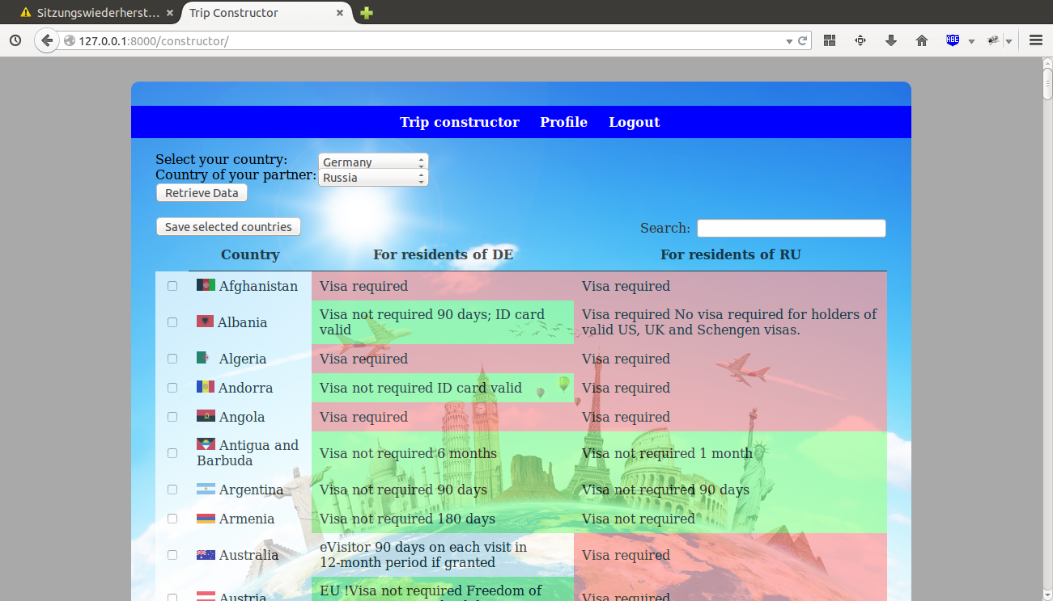
- Table can be sorted by Countries, and by visa requirements for user or his partner in both ascening and descending order by clicking on the title of the related column.
- Each record of the dataTable has a checkbox, which can be selected. After pressing button 'Save selected countries' the selected countries will be added in the user profile to the list of trips and notification will appear.
- Datatable has a field "Search". User can enter a string, containing name or a part of name of a country, and matching records will be displayed.
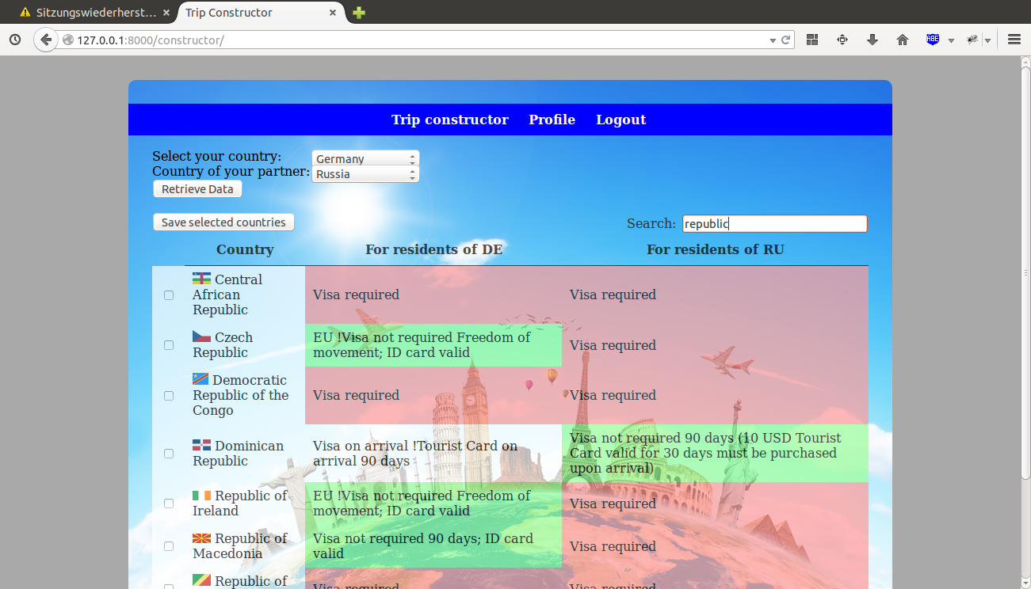
- The navigation panel on the top of the page contains 3 links – Trip Constructor, User Profile and Logout.
- By clicking Logout user will be logged out and redirected to the login page.
- By clicking Trip Constructor user will be redicted to the Trip Constructor page. If user is not logged in (for example, session has expired), he will be redicted to the login page.
- By clicking Profile user will be redicted to the Profile page. If user is not logged in, he will be redicted to the login page.

- The Profile page represents personal data of user and contains the following fields:
  - Profile picture, which can be selected by clicking 'Upload' or deleted by selecting checkbox 'Delete'
  - Country. If country is saved in the database, this country will be selected in the field 'your country' of the Trip Constructor page.
  - Username and password. If no password entered, it will not be updated.
  - All the changes are saved in the database after submitting form. Form submit can be done by clicking 'Save profile' or pressing Enter.
- User profile contains the table with countries which were saved on the Trip Constructor page. This table contains 5 columns – Destination, Your nationality, Your requirements, Partner's nationality, and Partner's requirements. This data can be also sorted by any of the columns in both ascending and descending order, and filtered by the keyword entered in the field 'Search'.

